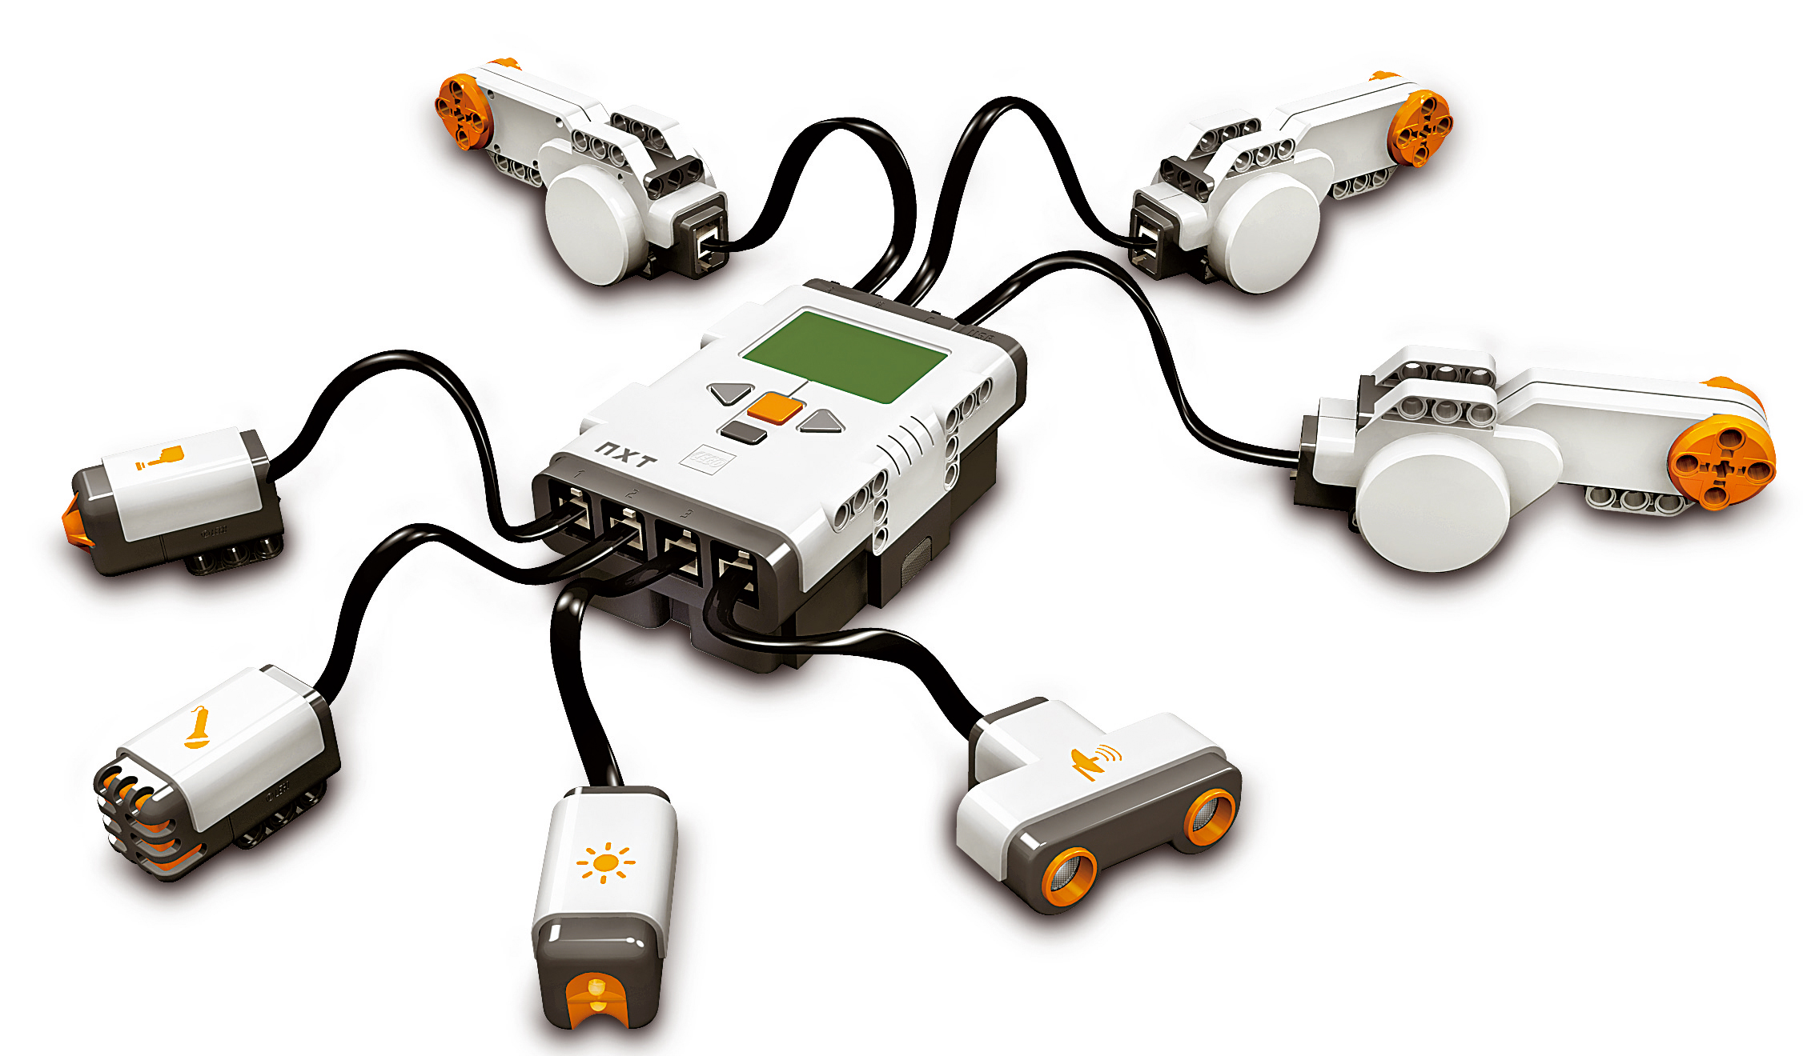
Lego NXT:
-Sonar
-Sound
-Light
-Bumper
-Motor
-Gripper

NXT Communications
-struct usb_device
-DevOpen()
-closeSensorOnPort()
-nxt_set_motor()
-nxt_set_motor_with_limit()
-openSonarOnPort()
-setSonorContinuousReadMode()
-getSonarValue()
-openLightActiveOnPort()
-openLightPassiveOnPort()
-getLightValue()
-openSoundOnPort()
-getSoundValue()
-openBumperOnPort()
-getBumperValue()

Player Driver
-MainSetup()
-Main()
-ProcessMessage()

